CLOCK DOMAIN CROSSING (CDC)

OBJECTIVE
This lab tends to familiarize students with the concept of metastability which occurs when using asynchronous inputs that crosses different clock domains. The manual discusses three main CDC techniques to avoid metastable states and how to keep the design foolproof with multiple clock inputs. After this lab students should be able to: estimate the effect of various design parameters on metastability MTBF and design synchronization circuits for single- and multi-bit signals.

TOOLS & LANGUAGE
- Xilinx Vivado 2019.1
- Verilog / System Verilog (SV)

INTRODUCTION

Metastability is caused when the set up and hold time requirements of a flip-flop aren’t met. The flip-flop then enters a state which is neither zero nor one, neither high nor low. It may be read by some of your logic as a zero, and by other parts of your logic as a one. Metastability, therefore, can cause your logic to do some very unpredictable and (apparently) illogical things. For the digital designer, metastability can take place any time a signal crosses from one clock domain to another. This is called a “Clock Domain Crossing”, or CDC, and it needs some special engineering to be done properly.

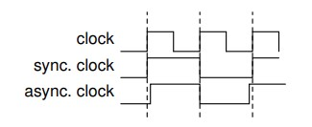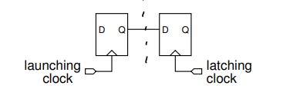

Fig. 1
When two clocks are asynchronous – independently generated – their clock edges will drift relative to each other. This means that it is guaranteed that at some point in time the setup and hold requirements of the latching clock will be violated. This will result in metastable behavior. As another example, consider a state machine with one-hot state encodings of 01 and 10. Metastable behavior could result in a transfer to an invalid state such as 00. The device would likely “lock up” in that state.
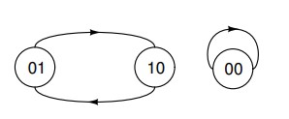
Fig. 2
Although it’s impossible to avoid metastable behavior, we would like to be able to predict its likelihood and find ways to reduce this probability to an acceptable level.

MTBF Calculation
Analysis and experimental results show that the mean time between failures (MTBF) due to metastable behavior of a flip-flop can be approximated by:
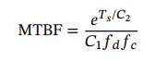
- Ts is the time available for the flip-flop output to reach a valid logic level.
- C2 is a function of RC time constants and circuit gains.
- C1 is a time constant proportional to the time interval during which an input transition could cause a metastable output
- fd is the average rate at which the flip-flop input (D input) changes
- fc is the latching flip-flop clock frequency

CDC Methods

Multi-flop Synchronizer
The most common way to increase the MTBF is to use two flip-flops in series to build a “synchronizer”:
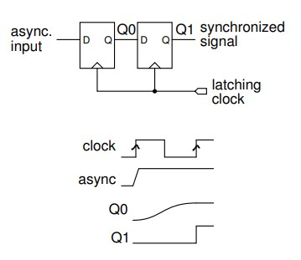
Fig. 3
The use of two flip-flops with no intermediate delays allows for a settling time Ts, approximately equal to one clock cycle. This is usually sufficient to ensure a sufficiently high MTBF at the output of the second flip-flop. However, if necessary, additional flip-flops can be placed in series. An unavoidable consequence of using a synchronizer is that one (latch) clock cycle of delay is added to the signal.

Data Coherency
To synchronize the transfer of multiple bits you might be tempted to use multiple single-bit synchronizers in parallel. However, this approach can fail when the input changes close to the latching clock edge. Even if the output of each synchronizer output settles to a valid logic level, each synchronizer could settle to either the value before or after the input change. The binary value latched by this (bad) multi-bit synchronizer could be completely different than the value launched.

Four-Phase Handshake
Reliable transfer of multi-bit data can be done using a “four-phase handshake.” This requires generating a request status signal along with the data and using an acknowledge signal to indicate that the data has been captured. Both req and ack need to be synchronized because they cross clock domains.
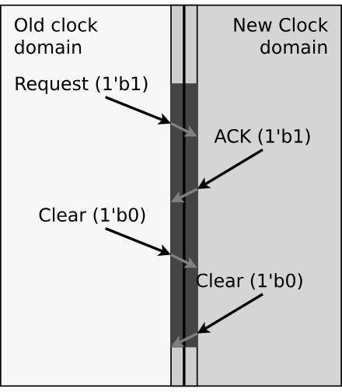
Fig. 4
The sequence of events is:
- req is asserted at the same time that the data is output
- ack is asserted after the data has been captured; this requires two (latching) clock cycles to ensure data coherency
- req is de-asserted to prepare for the next transfer
- ack is de-asserted to indicate that the receiver is ready for the next transfer
This method works regardless of the frequencies of the two clocks. However, the one- to twocycle delay per transfer that is required to synchronize changes on the handshaking signals limits the transfer rate.

Asynchronous FIFOs
When faster CDC transfers are required, an asynchronous FIFO – a FIFO with independent read and write clocks – can be used. This requires a dual-ported memory with independent read and write ports. The design of an asynchronous FIFO is relatively complex because it’s necessary to transfer read and write pointers between clock domains. However, a FIFO allows for the fastest possible transfer rate – one word per read or write clock. For such a FIFO, you need to keep the source from writing if the FIFO is full, and you need to keep the sink from reading the output when the FIFO is empty–and both of these conditions depend on knowing information from the other side of the FIFO.

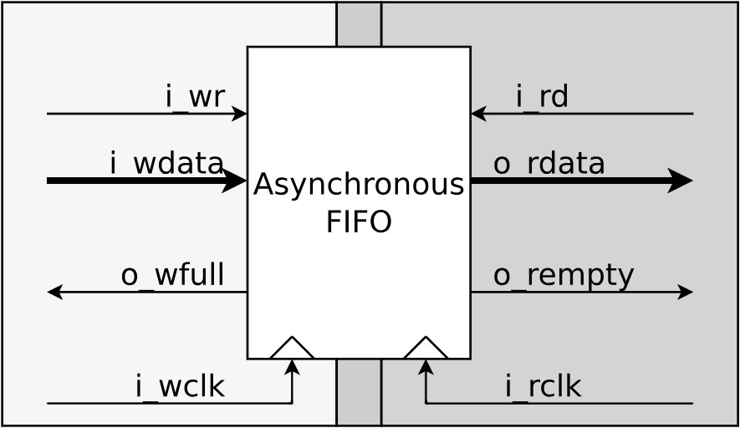

Fig. 5

Lab Tasks
For each of the tasks below, generate a bit-stream and run on the FPGA board!

Pre-requisites
To perform this lab, you need to first create a clock generator module that operates on the FPGA clock 100MHz. The outputs from this module are two dissimilar clocks; 25 MHz for clk_a and 30 MHz range for clk_b with arbitrary phases and frequencies. Use a counter for each clock that increments w.r.t the system clock. Assign [N-1] bit of these counters to the specified clock outputs for a 50% duty cycle.

Task1: Dual-flop synchronizers
- Create a pulse generator that generates pulse transitions 0->1 in the old clock domain (25MHz). The new clock domain (30 MHz) monitors this signal and counts the number of times that the pulse transitions from 0 to 1.
- Add a dual-flop synchronizer to the pulse signal so that it is synchronized with the new domain.
- Simulate your design with testbench to see if the pulse count in old clock domain matches the count in the new domain.
Part of multiple clock domains is to also synchronize the reset so that all components of the design exit the reset state at the same time. Design a synchronous active high reset based on asynchronous active low reset, where the circuit asserts the reset high when active low reset is enabled and takes 3 clock cycles to exit from reset.

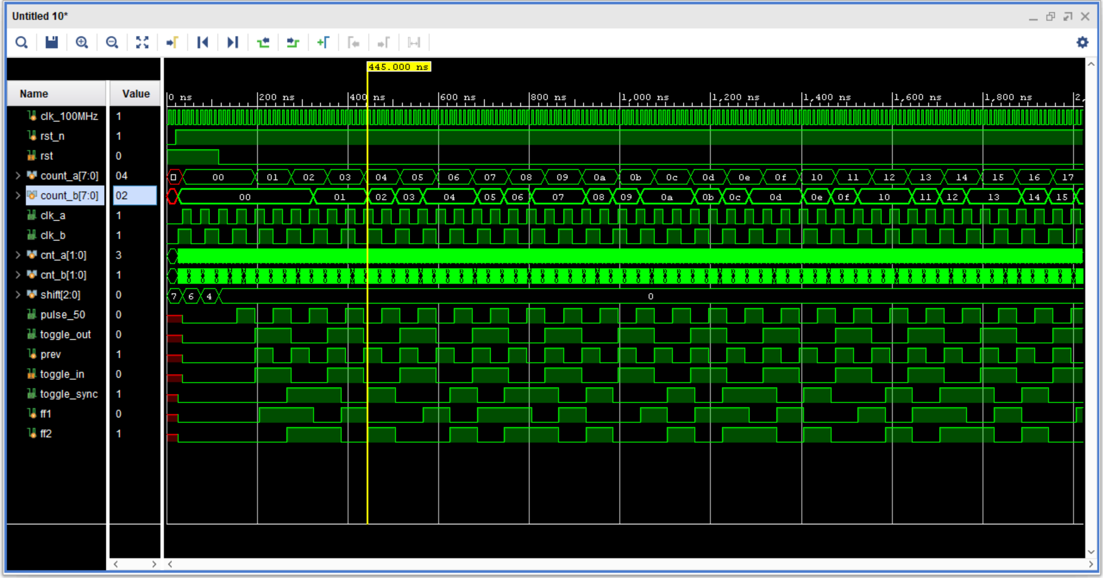
OUTPUT WAVEFORM
- The dual FF synchronizer, counting data according to the clk it has provided.
- The clk_a and clk_b are generated by a 100MHZ clock.
- The edge detector is also working great as it is storing prev signal value and also active low toggle_in to detect the positive edge.
- Lastly we get 25MHZ and 30MHZ clocks from 100MHZ clock.
- No double counting observed (metastability handled properly).
- Old domain count and new domain count appear consistent (no pulse loss).

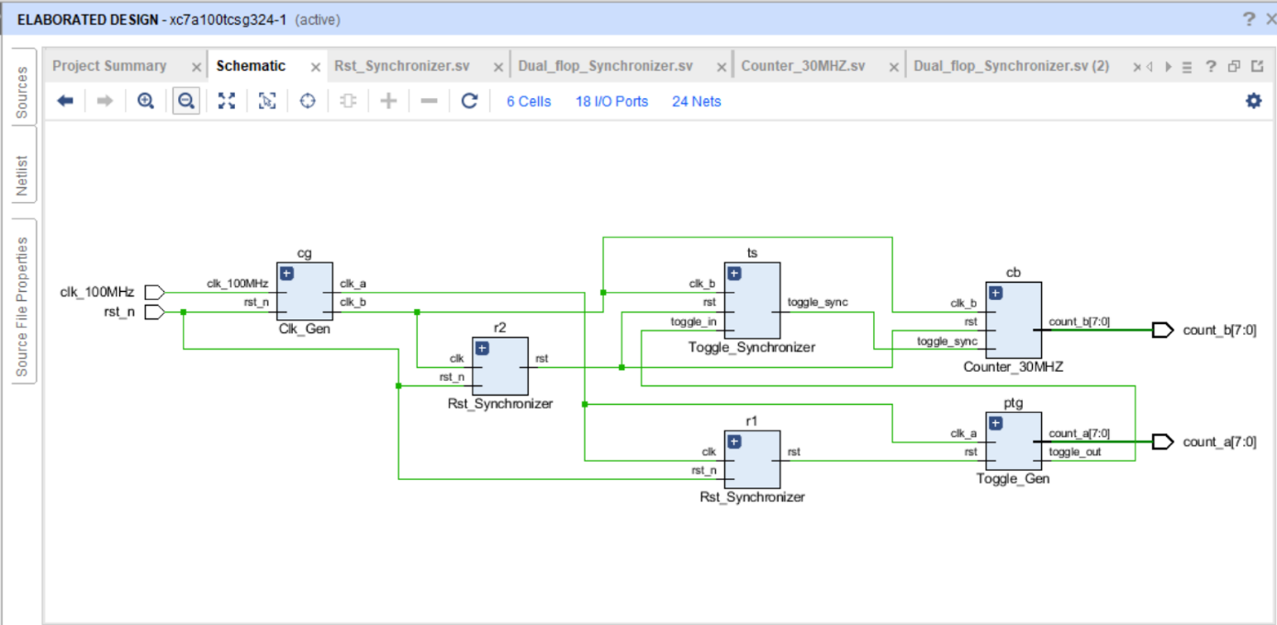
ELABORATED DESIGN
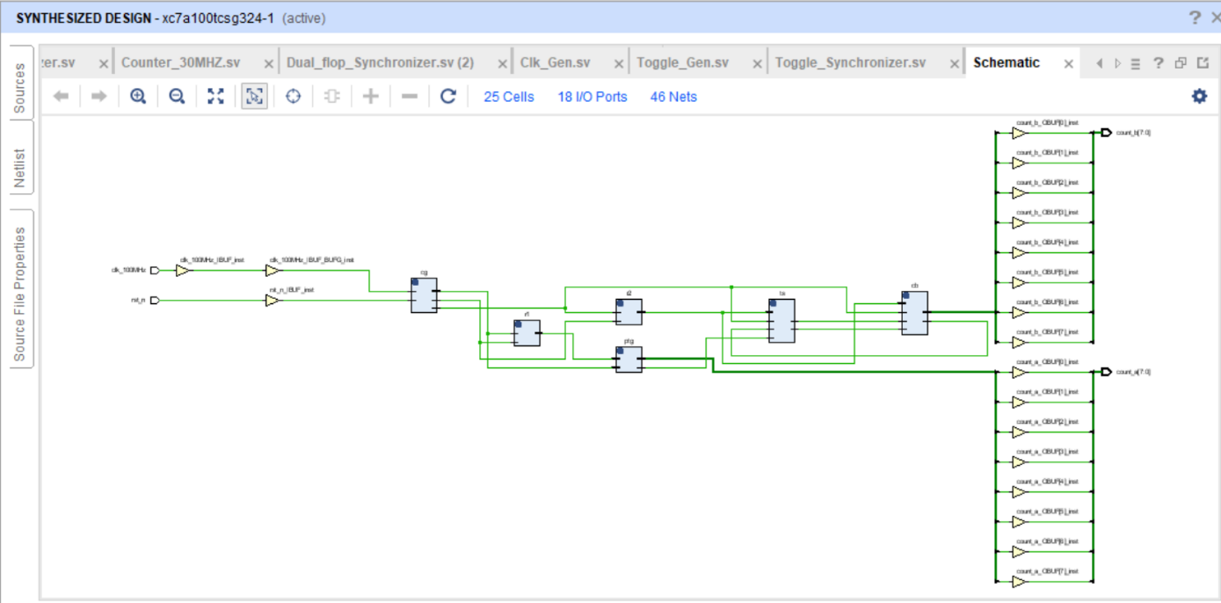
SYNTHESIZABLE DESIGN

Task2: Handshake synchronizers
The dual-flop synchronizer cannot reliably be used to transfer multiple-bit signals. To deal with multi-bit signals, one form of synchronization is a handshake. For this task, you are required to implement a four-phase handshake synchronizer that transfers multiple bits of data from old clock domain to the new clock domain:
- Create an 8-bit counter in the slow clock domain that increments only when the pretransfer signal (valid_data) is de-asserted. This is done so that all counter values are
sampled in the faster updated clock domain.
- Use dual-flop synchronizers to communicate handshake signals between the source and destination domains. The destination domain should only send back acknowledgement once all the data is transmitted.
- Run simulation and visualize that the data received in the new clock domain corresponds to the data generated in the new clock domain.
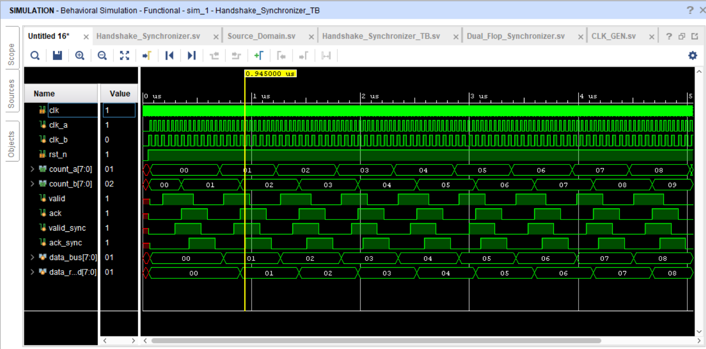

- Valid signal behavior: valid_data goes HIGH when the source (slow clock domain) places a stable 8-bit counter value on the bus, and remains HIGH until acknowledgement is received.
- Counter operation: The 8-bit counter increments only when valid_data = 0, ensuring data remains stable during transfer and no values are skipped.
- Synchronization delay: Due to dual-flop synchronizers, both valid_data and ack signals show a 2-clock cycle delay when crossing clock domains.
- Data capture in fast domain: The destination (fast clock domain) samples the data only when synchronized valid_data is HIGH, ensuring correct and stable data reception.
- Acknowledgement handshake: After capturing data, the destination asserts ack, which is synchronized back to the source, completing the transfer cycle.

ELABORATED DESIGN
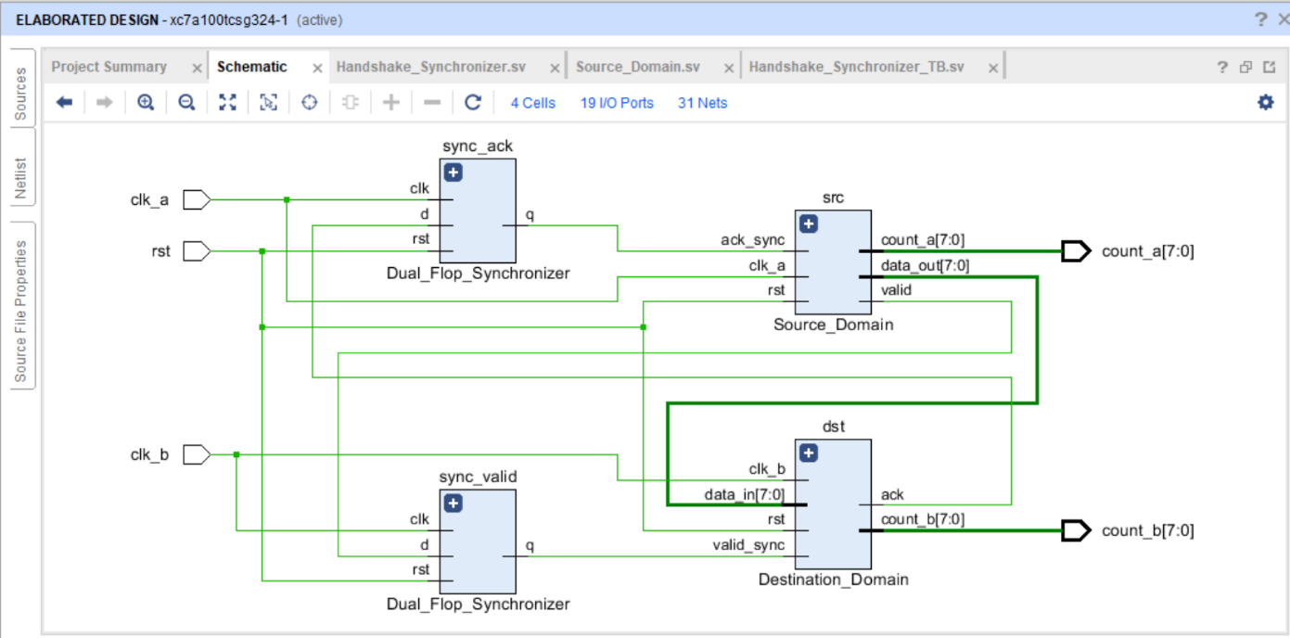

SYNTHESIZABLE DESIGN
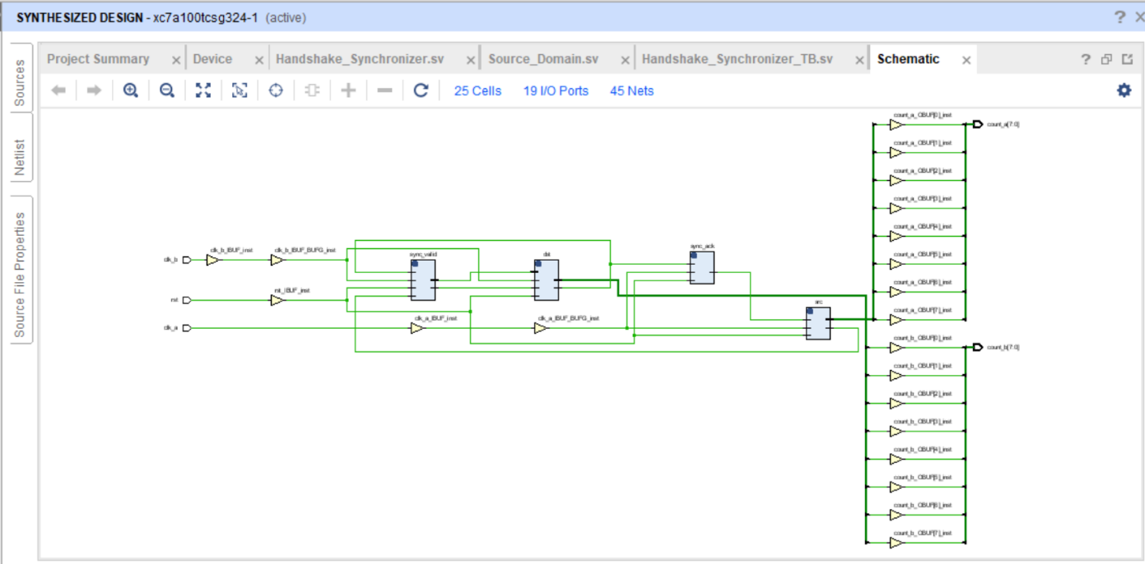

TASK3: Asynchronous FIFO
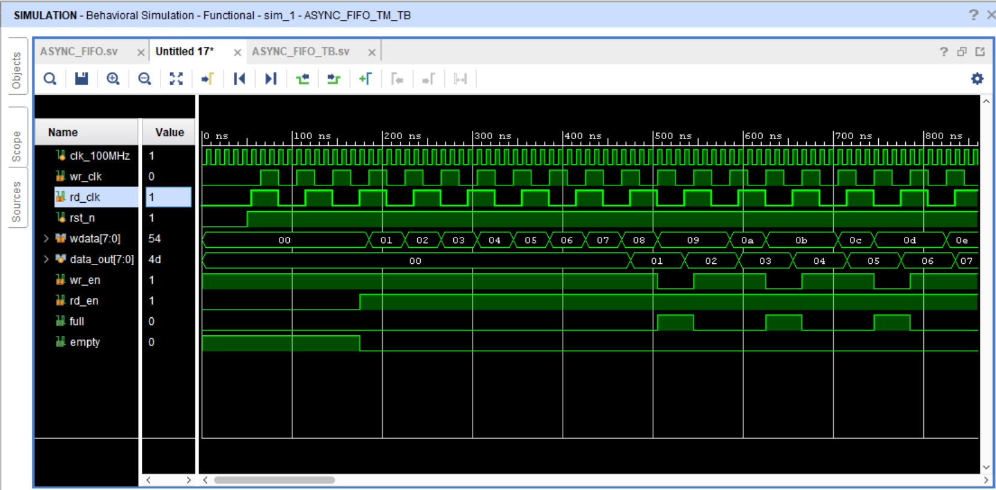
Although the handshake enables arbitrarily wide data to be transferred across clock domains, it can reduce throughput and complicates control. One way of dealing with this problem is to add a buffer or FIFO that stores data in the destination domain so that the source can immediately start a new transfer. Such a FIFO provides a different clock domain for reading and writing. Instead of using the handshake synchronizer, transfer count values using an asynchronous FIFO between the source and destination domain. The counter should stop incrementing if the FIFO is full. The source domain should write to the FIFO using old clock (25MHz) and the destination should read the transmitted data using the new clock (30MHz). For this task, ensure:
- Dual Clock Domains: Write at 25 MHz, read at 30 MHz.
- Gray Code Pointers: Ensures stable address transfer across domains.
- Pointer Synchronization: Dual-flop synchronizers prevent metastability.
- Full/Empty Control: Stops write when full, stops read when empty.
- Synchronized Reset: Single reset safely initializes both domains.

ELABORATED DESIGN
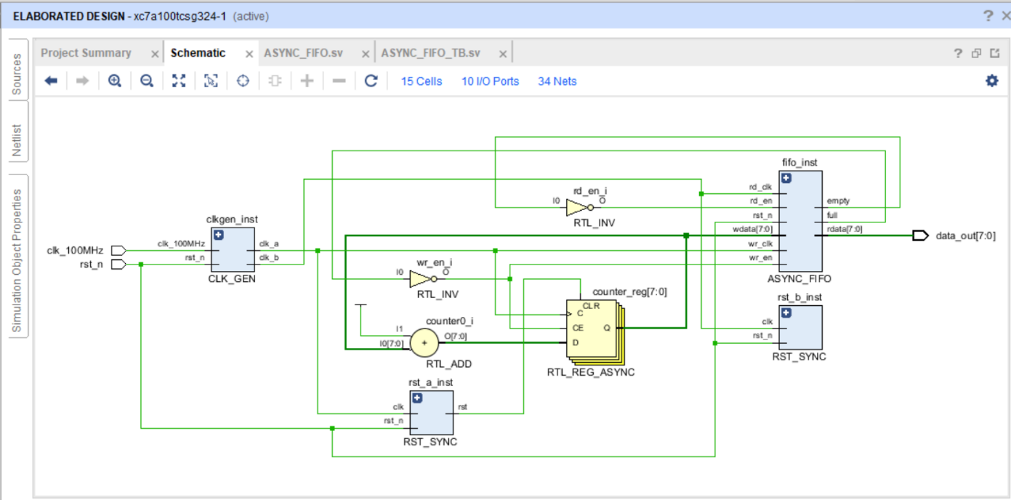

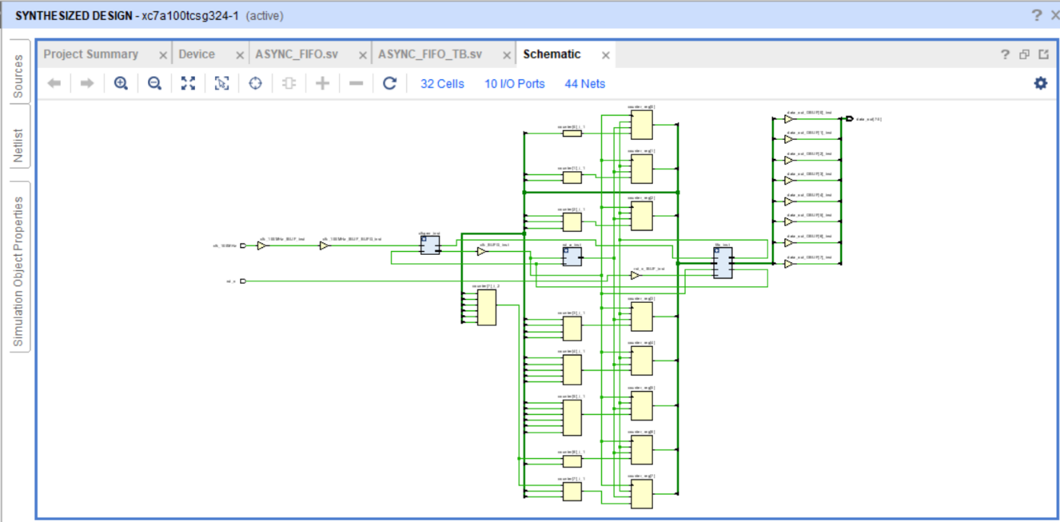
SYNTHESIZABLE DESIGN

TASK 4: CLOCK SWITCH DESIGN
A clock switch is a design component that takes two clock inputs and a switch input, and produces one of the two clocks as its output dependent upon how the switch is set. Clock switches are very important parts of a failsafe designs. A failsafe design can start with one clock and then switch to the second clock once it stabilizes. In a similar fashion, if the second clock becomes unstable or otherwise unusable, then the clock switch should return the design to the original clock.
- Create a clock switch design using multi-flop synchronizers that splits the clock select line and synchronizes it w.r.t the corresponding domain.
- Use the split clock select and the clock domain to generate the output.

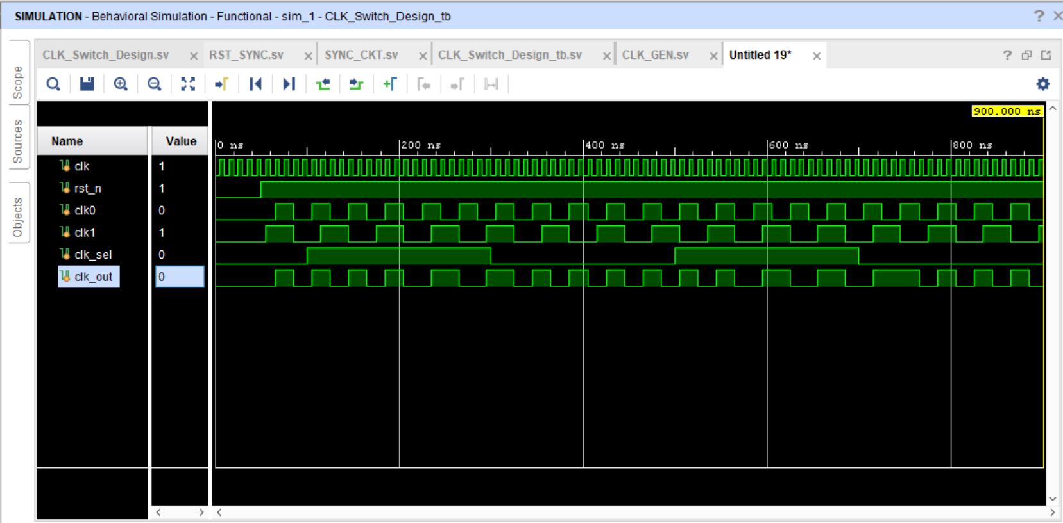

- Dual Clock Inputs: Selects between two clocks for failsafe operation.
- Switch Control: Clock selection depends on the synchronized switch signal.
- Multi-Flop Synchronizers: Prevent metastability of the clock select line.
- Split Clock Select: Separate signals for each clock domain to ensure safe switching.
- Failsafe Switching: Automatically returns to original clock if the alternate clock fails.

ELABORATED DESIGN

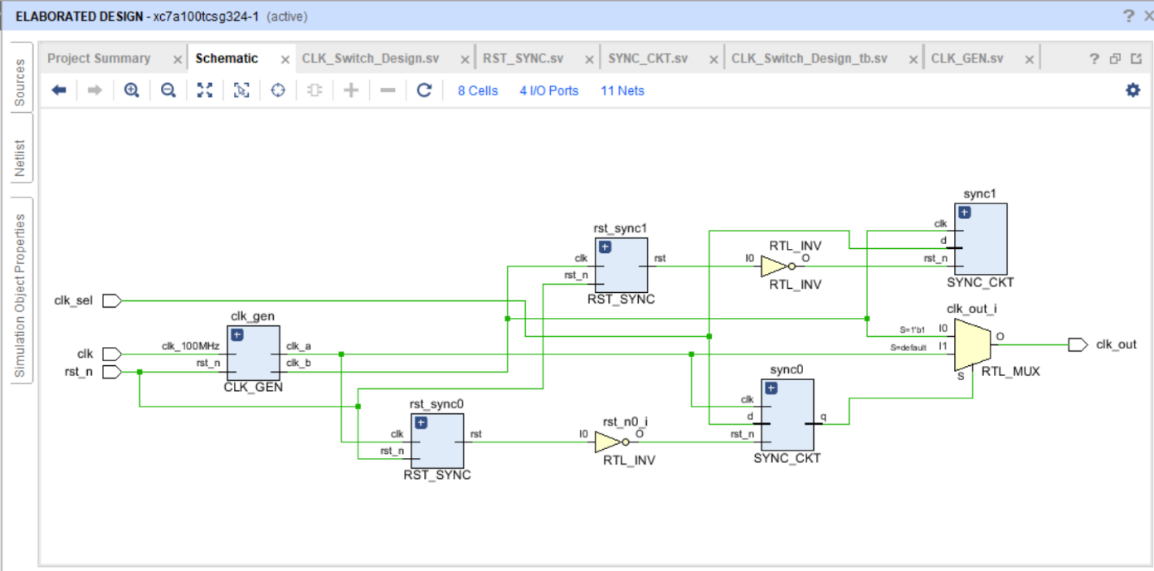

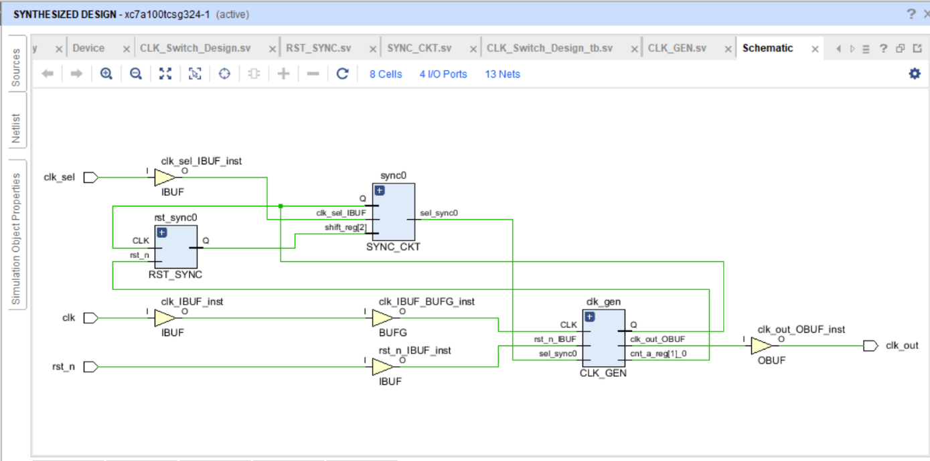
SYNTHESIZABLE DESIGN

CONCLUSION (THINGS I LEARNED)

- Learned metastability and why signals crossing clock domains need careful handling.
- Implemented dual-flop synchronizers for single-bit CDC signals.
- Used four-phase handshake to safely transfer multi-bit data.
- Designed asynchronous FIFO with Gray-coded pointers for high-speed CDC.
- Managed full/empty conditions in FIFO to prevent overflow/underflow.
- Built a clock switch with multi-flop synchronizers for failsafe operation.
- Learned to synchronize reset across multiple clock domains.
- Understood MTBF and reliability trade-offs in CDC circuits.
- Gained hands-on SystemVerilog simulation and FPGA implementation skills.
- Learned system-level CDC design, balancing throughput, latency, and reliability.

